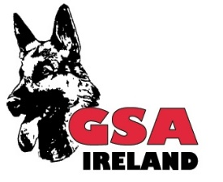 | THE NATIONAL GERMAN SHEPHERD WORKING DOG ASSOCIATION –  GSA IRELAND LTD.  MEMBER OF THE WORLD UNION GERMAN SHEPHERD ASSOCIATION – WUSV

APPLICATION TO HOST AN APPROVED EVENT

TYPE OF EVENT: IPO TRIAL BREED SHOW BREED SURVEY SEMINAR OTHER

Organizing OG

Type of Event:

Proposed dates/s
Provide alternative dates

Show/Trial Secretary Show/Trial Manager
Name: |  | Name:
Address: |  | Address:
Tel no: |  | Tel no:

This form accompanied by the required fee €20 must be received by the General Administrative Secretary GSA Ireland Ltd at least 12 weeks before the proposed event dates. OG can make suggestions or proposals for selection of the Judge/s with final approval and appointment by the Executive Officers, GSA Ireland Ltd. Application for WUSV registered Judges must be received by the General Administrative Secretary GSA Ireland Ltd at least 10 weeks before the event date. The processing fee per judge to 8 weeks before the event is €150.00 the processing fee per judge to 4 weeks before the event is €300.00

Judge’s name:

Address:

Tel no: |  | e-mail:
Judge contacted by GSA Ireland Ltd on: |  | Judge confirmed by GSA Ireland Ltd on:

Helpers
Name: |  |  | Name:
Address: |  |  | Address:
Tel no: |  | e-mail: | Tel no: |  | e-mail:

Tracklayers
Name: |  |  | Name:
Address: |  |  | Address:
Tel no: |  | e-mail: | Tel no: |  | e-mail:

GSA OG Secretary’s Signature: | Date:

Office use only | Confirmed | Received on: | Fee enclosed

